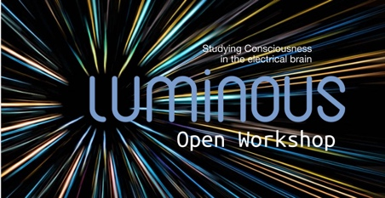
Studying, Measuring and Altering Consciousness
21 November 2019
Merton College, University of Oxford

8.30-9.00 | Registration
9.00-9.10 | Welcome
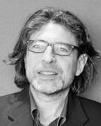  9.10-9.30 | Aureli-Soria Frisch – Luminous: A study of consciousness in the electrical brain  Starlab Barcelona, http://starlab.es, Barcelona, Spain  Email: aureli.soria-frisch@starlab.es
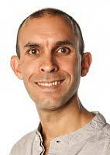  9.30-10.10 | Keynote Speaker: Anil Seth - “Title TBC”  Professor of Cognitive and Computational Neuroscience and Co-Director, Sackler Centre for Consciousness Science, University of Sussex, UK  Email: A.K.Seth@sussex.ac.uk
10.10-10.30  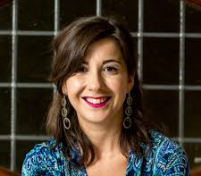 | Athena Demertzi – The ethical imperative of studying Consciousness  GIGA Institute | GIGA Consciousness | Physiology of Cognition Research Lab, University of Liège, Belgium  Email: a.demertzi@uliege.be
10.30-11.00 | Refreshments
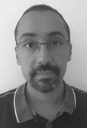  11:00-11:20 | Julien Modolo – Can we use computer models of brain activity to understand how consciousness emerges and vanishes?  Laboratoire Traitement du Signal et de l’Image (Rennes), INSERM / National Institute for Health and Research in Medicine, France  Email: julien.modolo@gmail.com
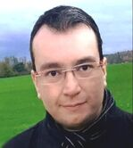  11.20-12.00 | Keynote Speaker: Hector Zenil – Algorithmic Complexity and Cognition  Director, Oxford Immune Algorithmics, Oxford; Lab Leader, Algorithmic Dynamics Lab, Center for Molecular Medicine, Karolinska Institute, Stockholm; Head of Group, Algorithmic Nature Lab, LABORES for the Natural and Digital Sciences, Paris.  Email: hector.zenil@ox.cs.ac.uk
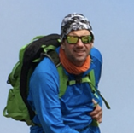  12.00-12.20 | Giulio Ruffini – KT: an algorithmic information theory of consciousness  Starlab Barcelona, http://starlab.es and Neuroelectrics, http://neuroelectrics.com, Barcelona, Spain  Email: giulio.ruffini@starlab.es
12.20-12.40 | Flash talks of submitted Abstracts
12.40-1.40 | Lunch

1:40-2:10  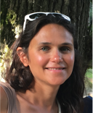 | Keynote Speaker: Claire Sergent - From subjective experience to brain activity, and return  Associate Professor, Integrative Neuroscience and Cognition Center, Université Paris Descartes & CNRS, Paris, France  Email: claire.sergent@parisdescartes.fr
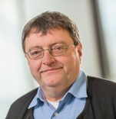  2.10-2.30 | Hubert Preissl – Are there signs for conscious processing in the fetal brain?  MEG Center/Internal Medicine IV/Institute for Diabetes Research and Metabolic Diseases of the Hemholtz Center Munich, University of Tübingen & German Center for Diabetes Research, Tübingen, Germany, http://preissl-lab.net/  Email: hubert.preissl@uni-tuebingen.de
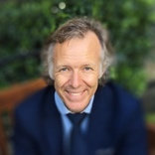  2:30-3:10 | Keynote Speaker: Morten Kringlebach – Awakening: predicting perturbation to force  transitions between different brain states  Associate Professor, Hedonia Group, University of Oxford, UK  Professor of Neuroscience, Aarhus University, Denmark  Email: morten.kringelbach@queens.ox.ac.uk
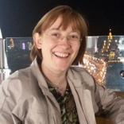  3:10-3:30 | Silvia Casarotto - Assessing consciousness through cortical perturbations  Department of Biomedical and Clinical Sciences "L. Sacco", University of Milan, Italy  Email: silvia.casarotto@unimi.it
3.30-4.00 | Refreshments
4.00-4.20  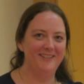 | Katie Warnaby – Slow waves and anaesthesia-induced unconsciousness  Wellcome Centre for Integrative Neuroimaging, Nuffield Department of Clinical Neurosciences, University of Oxford, UK  Email: katie.warnaby@ndcn.ox.ac.uk
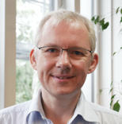  4.20-4.40 | Michael Nitsche - Transcranial electrical stimulation to modulate sleep-dependent processes  Department of Psychology and Neurosciences, Leibniz Research Centre for Working Environment and Human Factors (IFADO), Dortmund, Germany  Email: nitsche@ifado.de
4:40-5:00  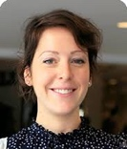 | Aurore Thibaut – Non-invasive brain stimulation to promote consciousness in the injured brain  GIGA Institute | GIGA Consciousness | Physiology of Cognition Research Lab, University of Liège, Belgium  Email: athibaut@uliege.be
5.00-5.20  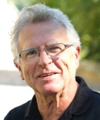 | Niels Birbaumer – Brain Computer Interfaces in complete paralysis: rebirth of the grandmother cell  Institute of Medical Psychology and Behavioral Neurobiology, University of Tubingen, Germany  Email: birbaumer@uni-tuebingen.de
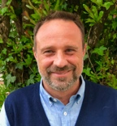  5.20-5.30 | Marcello Massimini – Concluding Remarks  Department of Clinical and Biomedical Sciences  University of Milan, Italy  Email: marcello.massimini@gmail.com

